**DOCTOR**

**PROJECT GROUP MEMBER**

|  |  |
| --- | --- |
| **Students Id** | **Students Name** |
| ***Student1449863*** | ***M.ADEEL CHOWDHRY*** |
| ***Student1452450*** | ***M.ALI*** |
| ***Student1413553*** | ***MURTAZA*** |
| ***Student1450989*** | ***ABDUL SAMAD*** |

**CURRICULUM BATCH**

**7062 2301C2**

**FACULTY**

**SIR HARIS NASEER**

**CO-ORDINATOR**

**MISS MAHA HAIDER**

**LOGIN**

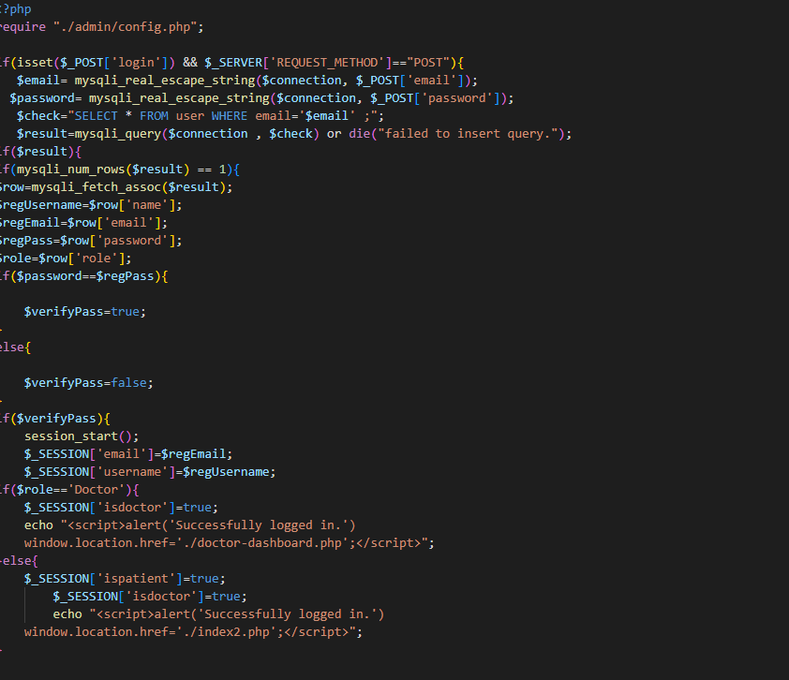

**REGISTER**

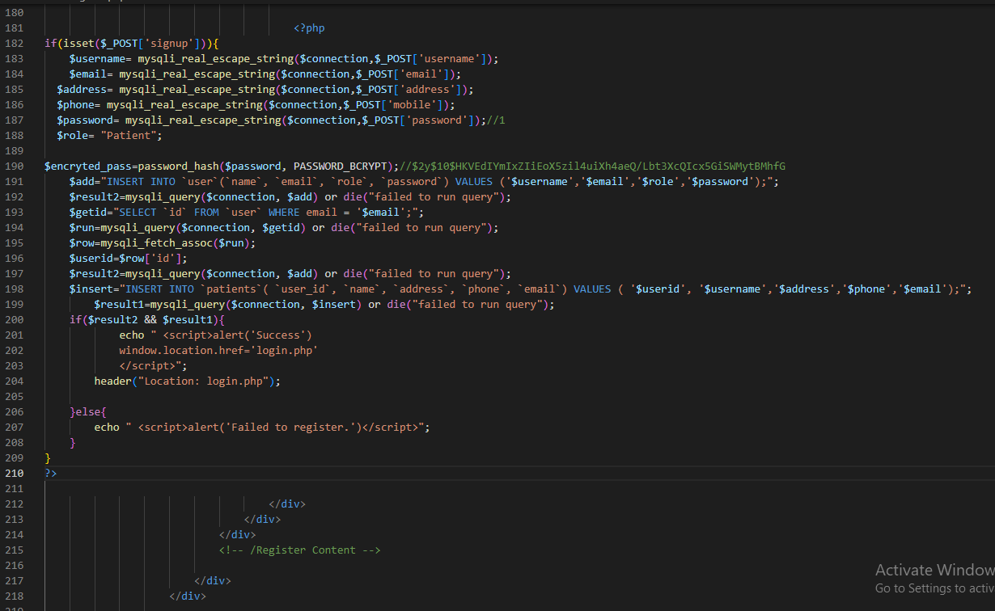

**LOGOUT**

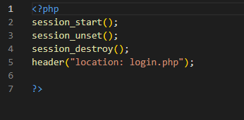

**FORGOT PASSWORD**

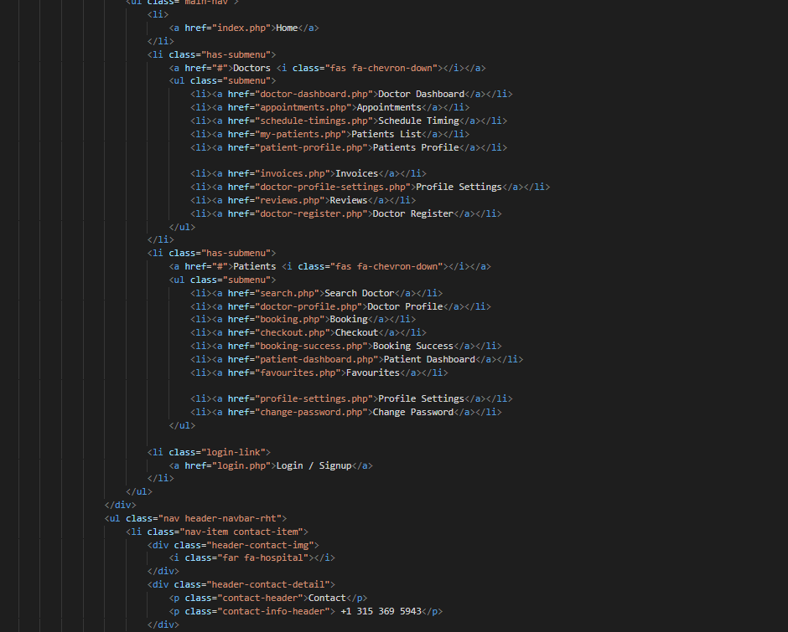

**ADMIN LOGIN**

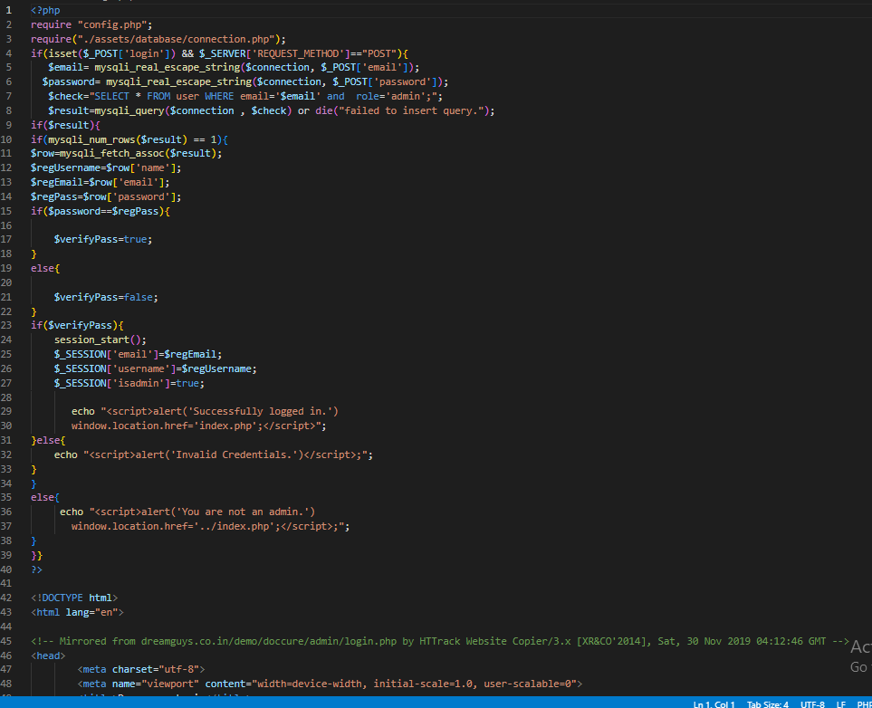

**ADMIN REGISTER**

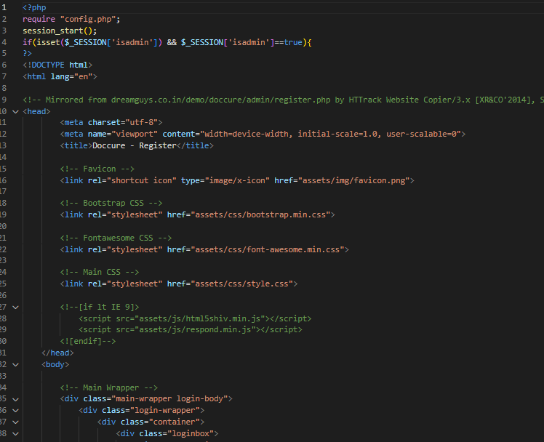

**ADMIN FORGOT PASSWORD**

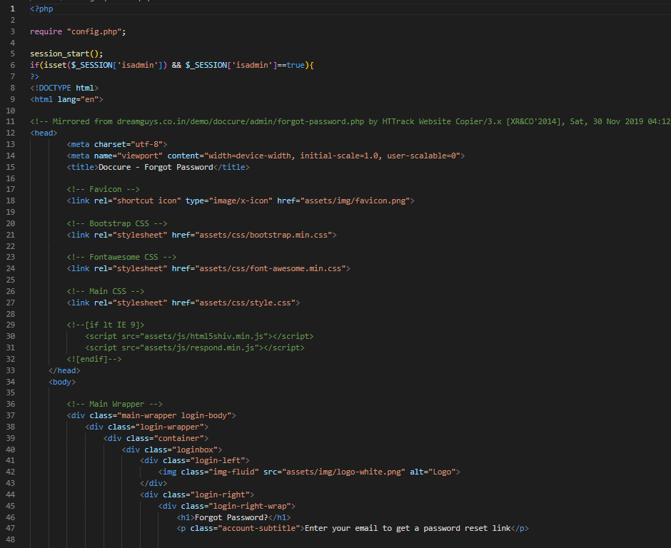

**ADMIN LOGOUT**

